

BAHIRDAR DAR UNIVERSITY

BAHIRDAR INSTITUTE TECHNOLOGY

FACULTY OF COMPUTING

SOFTWARE ENGINEERING TOOLS ASSIGNMENT

Group Member Id Section

Endaweke Enkuahone 1102197 A

Endalamaw Shiferaw 1101922 A

Atsedewin Molla 1102196 A

Desalegn Sisay 1102511 A

Yabsira Ayichluhim 1102283 A

Abebe Tafwere 1101973 A

1. **Acknowledgment**

First of all we would like to thanks our God to his eternal help. We would like to express our special thanks of gratitude to our teacher Mr. Mintesnot who gave us the opportunity to do this wonderful project and help as to know more about Software engineering tools and practice and for his continuous expert advice.

Secondly, we would like to thank dr. Asnake ,who is manager of Bahirdar University college ofbusiness and economics campus clinic, for his support by giving the information that we need.

Lastly, we would like to thank for our group members for all their hard work and great participation to do this assignment or project.

1. **Introduction**

This project is focus on Bahirdar University college of business and economics campus clinic management information system. In this project we try to include all the necessary things and concepts that are used to develop a computerized system like

Make requirement analysis and specify requirements using the user story

format. Draw use case, class and sequence diagram that represent static and dynamic

nature of our project. Generate source code from class diagram using ArgoUML.

Integrate our project into github and show the command using Gitbash. Make unit Test using junit framework. Build our project using Apatch Ant. This clinic used a manual clinic management system. This clinic gives a service for only regular students in the campus. The clinic consists of nurses, doctors, receptionist, pharmacist, lab assistant, security guards and a manager, totally employees.

**Requirement specification**

**Functional requirement**

The functional requirement for BahirDar university (peda) clinic

Management information system is:

Manger

* The manger should able to update drugs from database
* Record the drugs according to their drug type
* Assign the drugs - arranging the drugs by name
* Able to update employee information from database The system
* The system should save the data into database.
* The system should to generate error login.
* Display an error message

The system

* The system should save the data into database.
* The system should to generate error login.
* Display an error message
* Search information about the customer of the drugs
* Delete recorded drugs or order drugs
* Search drugs by drugs type for customers Calculate price
* Delete records when the drug reach expire date

Customer

* The patients order drugs and take drugs
* The system should allow Search drugs by drug type
* The system should allow the customers record information

Pharmacist

* The pharmacist search drugs by id and name
* The system displays drugs when it searched
* The pharmacist sells drugs for customer
* The pharmacist gives recite for customer
* Check the list of drug in the system
* Report to the manager about drug status

Nurse

* Given drug information to patient
* Assist the pharmacist in check and authorize

Non-Functional requirement

* The non-functional requirements deal with the quality of the application
* The system need to develop from different evaluation point of view.
* Non – functional requirement determines the system performance.

Some of the non- functional requirements are: -

* The system should easily adapt the environment or use local language
* The system uses as little as possible memory and respond to user with reasonable time delay
* The system should be able to work in any access able LAN network
* The system must be strongly secure to resist cyber attack
* The system should be easily maintainable
* The system should be user friendly

User requirement

When the project prepares uses some tools, Such as

hardware and software tools.

Hardware tools: -

Desktop or laptop computer

Flash or CD

Printer

Software Tools:

* Microsoft word
* Note pad
* Argo UML
* GitHub

**Requirement analysis**

User stories only capture the essential elements of a requirement:

* Who it is for?
* What it expects from the system?
* Why it is important (optional)?

**User Story**

* As a manager,I would like to update drugs from database in order to check the expire date of drugs
* As a manager,I would like to Record the drugs according to their drug type in order to arrange correctly
* As a manager,I would like to Assign the drugs - arranging the drugs by name in order to access easily
* As a manager,I would like to Able to update employee information from database in order to manage employe

|  |  |  |
| --- | --- | --- |
|  |  |  |
|  |  |  |

* As a pharmacist ,I would like to search drugs by id and name
* As a pharmacist, Iwould like to sell drugs for customer
* As a pharmacist, Iwould like to give recite for customer
* As a pharmacist, Iwould like to check list of drug
* As a doctor, Iwould like to give drug information to Pationt
* As a doctor, Iwould like to assist the farmacist in check and Authorize
* As a patient, Iwould like to order drug and take drug

**Analysis model**

1. **Essential use case modelling**

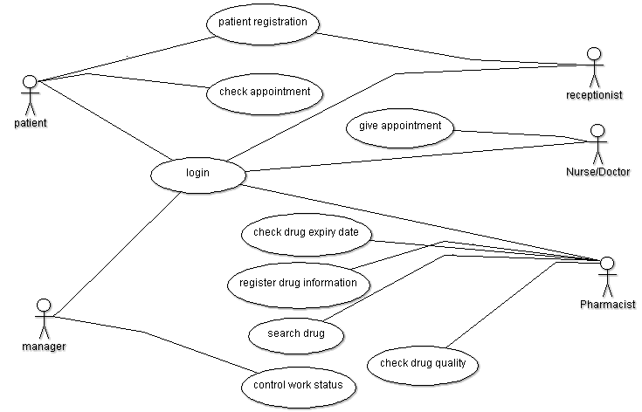

1. **System use case modeling**
   1. check appointment use case

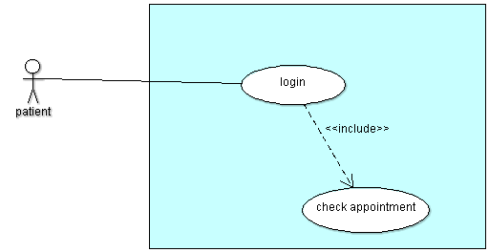

* 1. patient registration use case

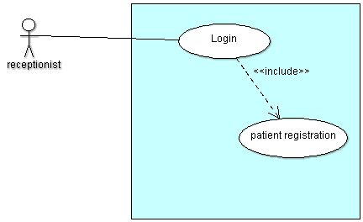

* 1. control work status use case

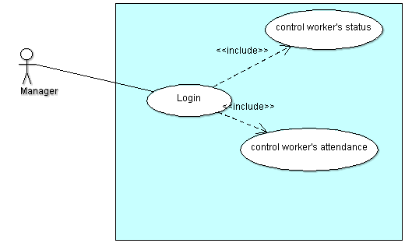

* 1. Give appointment

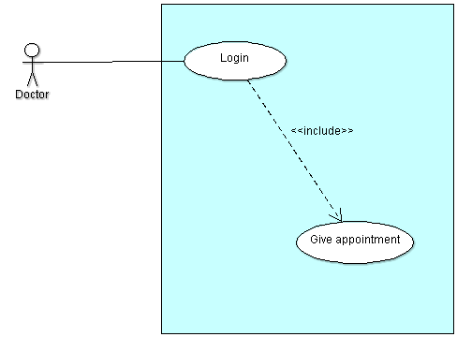

* 1. Drug use case

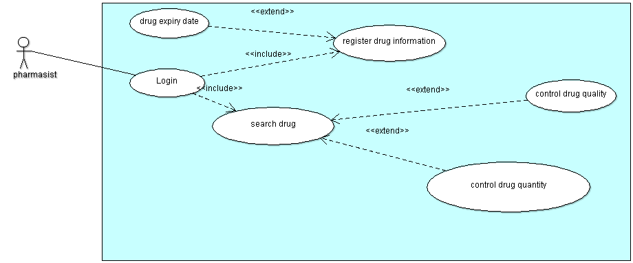

1. **Class Diagram**

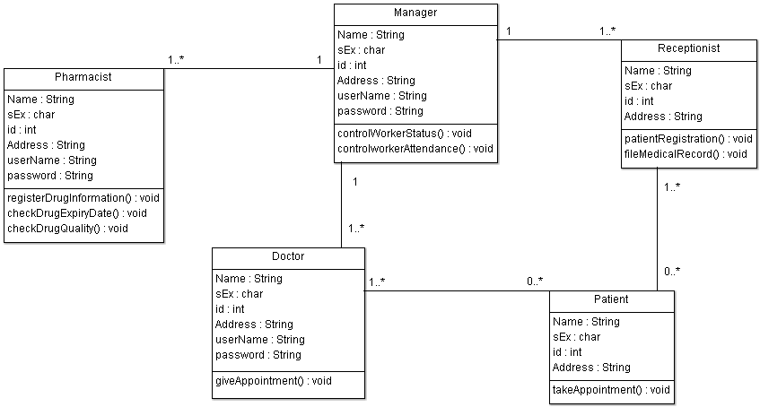

1. Sequence diagram

a. Check appointment

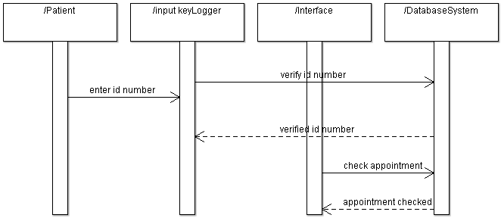

b. patient registration

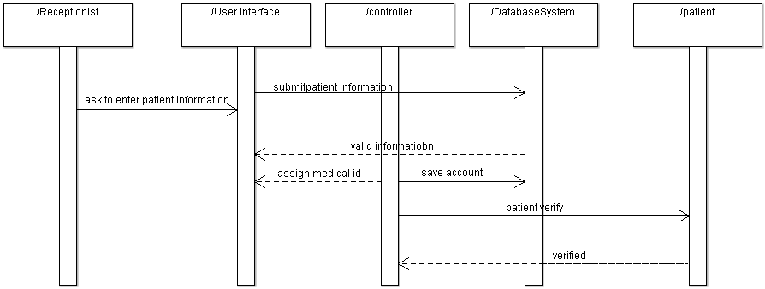

c. control work status

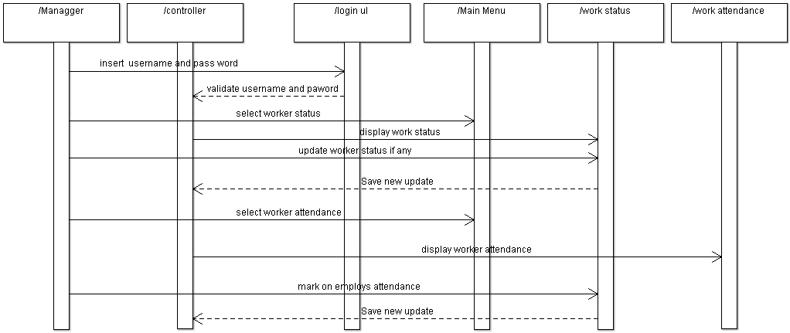

d. give appointment

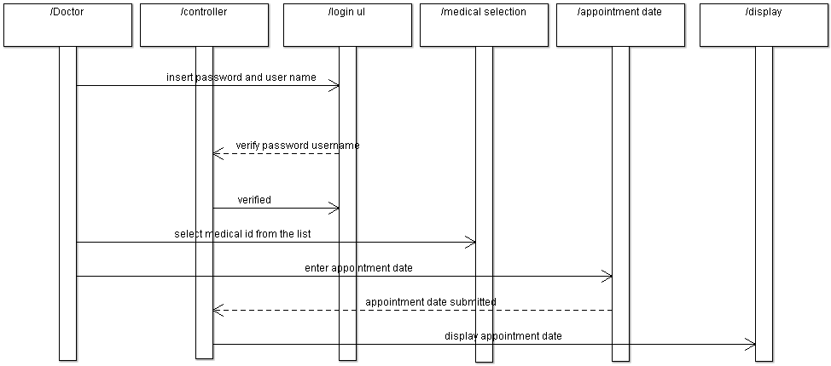

e. drug sequence diagram

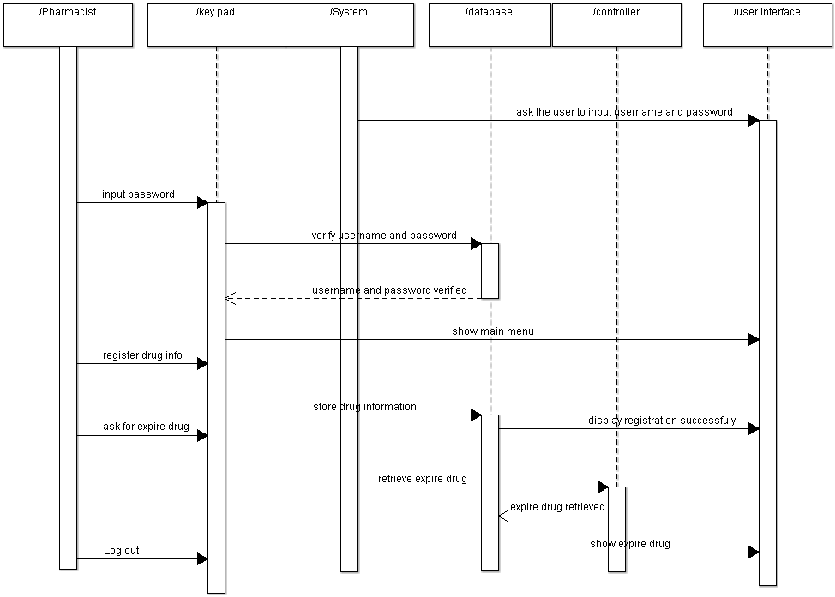

**GENERATED SOURCE CODE**

* + - 1. **Doctor’s generated source code**

**import java.util.Vector;**

**public class Doctor {**

**public String Name;**

**public char sEx;**

**public int id;**

**public String Address;**

**public String userName;**

**public String password;**

**public Manager myManager;**

**/\*\***

**\***

**\* @element-type Patient**

**\*/**

**public Vector myPatient;**

**public void giveAppointment() {**

**}**

**}**

* + - 1. **Manager’s generated source code**

**import java.util.Vector;**

**public class Manager {**

**public String Name;**

**public String sEx;**

**public int id;**

**public String Address;**

**public String userName;**

**public String password;**

**public Vector myPharmacist;**

**public Vector myDoctor;**

**public Vector myReceptionist;**

**public void controlWorkerStatus() {**

**}**

**public void controlworkerAttendance() {**

**}**

**}**

* + - 1. **Patient’s generated source code**

**import java.util.Vector;**

**public class Patient {**

**public String Name;**

**public char sEx;**

**public int id;**

**public String Address;**

**/\*\***

**\***

**\* @element-type Doctor**

**\*/**

**public Vector myDoctor;**

**/\*\***

**\***

**\* @element-type Receptionist**

**\*/**

**public Vector myReceptionist;**

**public void takeAppointment() {**

**}**

**}**

* + - 1. **Pharmacist’s Generated Source code**

**import java.util.Scanner;**

**public class Pharmacist {**

**Scanner in =new Scanner(System.in);**

**public String Name;**

**public char sex;**

**public int id;**

**Boolean check=false;**

**public String Address;**

**public String userName;**

**public String password;**

**public Manager myManager;**

**public int registerDrugInformation(int d) {**

**return d;**

**}**

**public void checkDrugExpiryDate() {**

**}**

**public void checkDrugQuality() {**

**}**

**}**

* + - 1. **Receptionist’s generated source code**

**import java.util.Vector;**

**public class Receptionist {**

**public String Name;**

**public char sEx;**

**public int id;**

**public String Address;**

**public Manager myManager;**

**public Vector myPatient;**

**public String patientRegistration(String a) {**

**return a;**

**}**

**public void fileMedicalRecord() {**

**}**

**}**

**Unit test using Pharmacist sample class**

